BUILDING & VALIDATING ARIA SACT AND SUPPORT REGIMENS

Objective

The purpose of this Standard Operating Procedure (SOP) is to describe the procedure to be followed when building and validating adult and paediatric SACT regimens (referred to as SACT regimens) and symptom management plans (referred to as support regimens) in the ARIA electronic prescribing system (referred to as ARIA).

Scope
This SOP applies to all adult and paediatric SACT and support regimens including clinical trials

Responsibilities

- The ARIA system administrator is responsible for allocating and overseeing the building and validation of all regimens in ARIA and storing all associated documents.
- Regimen building must only be undertaken by a technician or pharmacist who was received and completed the necessary ARIA training
- Regimen validations must only be undertaken by a pharmacist (other than the builder if applicable), consultant and nurse who have received and completed the necessary ARIA training

Process
Build the regimen
- Ensure all the drugs you require are present in the ARIA formulary. If they are not, request them on form KMCCEP007 Adding, amending & deleting agents from the ARIA formulary from KMCC system administrator
- Decide if the regimen should be built as a SACT or support regimen. Regimens that contain SACT drugs should be built as regimens and those that don’t contain SACT drugs should be built as support regimens. Exceptions to this are when a SACT regimen will be used for substitution into another SACT regimen. In this case, the new regimen which will be used as a substitute will need to be built as a support regimen. Also, if the SACT regimen will be needed in addition to an existing SACT regimen for prescribing to patients with more than one cancer diagnosis then the new regimen will be built as a support regimen. If you are unsure which option to choose, contact the KMCC system administrator
- Decide how to build the regimen from the following options. If you are unsure which option to choose, refer to the system administrator for guidance.
- Build a new regimen from scratch: Select “New” button to open up the “New Plan” window.
- Amend a regimen: An existing regimen should be updated using the Amend button wherever possible however, if the Amendments Mandatory tick box is selected on the current live regimen then DO NOT AMEND the regimen. Instead, click the “Copy” button and untick the Amendments Mandatory option, before proceeding with the changes.
- Copy a regimen: Select this option if updating an approved regimen that has Amendments Mandatory ticked or if you wish to use the existing regimen to build a similar one.
- Build the regimen following the Method detailed below in table 1
- Once building is complete, contact the system administrator who will facilitate the regimen validations

Validate the regimen
- Pharmacist Planner check: The pharmacist can now check the regimen build in Planner following the method detailed in Table 1 below. Any amendments required should be sent to the builder for correction. Once complete, inform the KMCC administrator who will facilitate the consultant and nurse validations
- Consultant check: The consultant validation must be performed by a consultant specialising in the tumour site that the regimen treats. This validation checks the regimen details and prescribing functions, as specified in checklist 1 for SACT regimens or checklist 2 for support regimens. Consultants will need to use a specific test patient for validation, as assigned by the KMCC administrator. Any amendments required should be sent to the builder for correction. Once complete, return the completed and signed validation checklist 1 or 2 to the KMCC administrator who will facilitate the nurse validation
- Nurse check (This step is not performed for clinical trial regimens): The nurse validation must be performed by a specialist SACT or oncology nurse. The validation checks the regimen for any nursing/administration-related issues, as specified in checklist 3 below. Nurses will use the same test patient as the validating consultant. Any amendments required should be sent to the builder for correction. Once complete, return the completed and signed validation checklist to the KMCC administrator who will facilitate the nurse validation
- Pharmacist Manager check: The second part of the validation checks the regimen build in Manager following the method outlined in table 2 below. Once completed, return the completed and signed validation checklist to the KMCC administrator who will inform the KMCC system administrator of validation completion
- For clinical trial builds: Validations will be completed by the clinical trial pharmacist or specialist pharmacist who is overseeing the setup of the study. This is immediately followed by a validation by Principal Investigator (consultant leading on the study). There is no validation carried out by a nurse for clinical trial builds. Checks must be performed in the same way as for non-clinical trial builds with the nuances of the study being validated by a person well versed in the clinical trial protocol.

Approve the regimen for use
- KMCC system administrator or KMCC administrator file all validation documents in document management system
- The KMCC system administrator or, in their absence an appropriately trained pharmacist will make the regimen live for use on ARIA. In all cases the SOP KMCCEP004 must be followed to complete the go-live process

Limitations
Inpatient haematology regimens which include complex hydration and/or drugs to be administered continuously across more than one calendar day cannot be built in ARIA. Such treatments should be available as a paper protocol for prescribing for individual patients. Refer to KMCC system administrator for guidance if needed. Ensure that the total duration of the Internal agents does not exceed 10 hours a day for day case regimens

Reference Sources

Ensure that you have access to the following, as you will require them during the regimen build & validation:
- K&M SACT protocol or other reference document for the regimen.
- KMCCEP006 ARIA regimen classification guide for adult regimens
- KMCCEP001 Aria regimen building and validation process following protocol approval

METHOD
TABLE 1
ARIA PLANNER
LOG IN TO PLANNER: ENSURE THAT BOTH THE “FROM” AND “LOGIN TO” BOXES HAVE “MTW NHS TRUST” SELECTED FROM THE DROPDOWN MENUS.
OPEN PLAN WINDOW: IF THIS DOESN’T AUTOMATICALLY OPEN THEN SELECT “FILE - OPEN PLAN”. THE OPEN PLAN WINDOW LISTS ALL REGIMENS THAT HAVE ALREADY BEEN BUILT UNDER THE PLAN TYPE SELECTED IN THE DROP-DOWN MENU. THE STATUS COLUMN WILL INDICATE WHETHER THEY ARE PENDING (I.E. STILL BEING BUILT), IN TESTING OR APPROVED.
BUILDER: SELECT NEW, AMEND OR COPY AS NECESSARY (SEE ABOVE FOR GUIDANCE)
VALIDATOR: BEFORE COMMENCING VALIDATION, ENSURE YOU ARE IN RECEIPT OF A COMPLETED BUILDING CHECKLIST, THEN DOUBLE CLICK ON THE REGIMEN YOU REQUIRE THEN SELECT ‘DEFINITION’ FROM THE TOOL BAR
DO NOT COPY AND PASTE TEXT FROM WORD DIRECTLY INTO ANY WINDOW IN ARIA AS THIS WILL CAUSE A SYSTEM ERROR. INSTEAD, COPY FROM WORD INTO NOTEPAD THEN FROM NOTEPAD INTO ARIA. TABLES AND DIAGRAMS, SHOULD NOT BE ENTERED INTO ARIA, INSTEAD, REFERENCE SHOULD BE MADE TO WHERE THEY CAN BE VIEWED E.G. K&M SACT PROTOCOL
 | NEW PLAN WINDOW
 | Definition tab
1.1.1. | 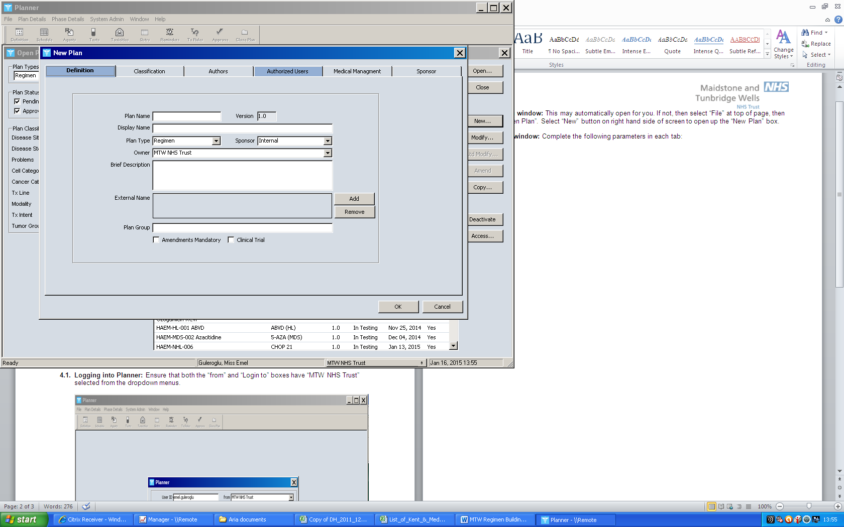  Plan Name: This box can only contain up to 20 characters and must be unique. The K&M SACT protocol number must be entered. On leaving the new plan window, this can then not be changed so ensure it is entered correctly.  1.1.1  1.1.3  1.1.2  1.1.4  1.1.5  1.1.6  1.1.7  1.1.8  1.1.9  1.1.10  1.1.11  For Clinical Trials the plan name should be a short-hand identifier for the trial, regimen name and/or arm.
1.1.2. | Version: The version number in this box will be automatically created and updated by ARIA.
1.1.3. | Display Name: This box will allow you to enter more information than the plan name box (80-character limit). This name is displayed in most user windows in Manager. The K&M SACT protocol number must be entered first followed by the protocol name, e.g. BRE-009 FEC75 (refer to protocol or KMCC regimen list). The protocol name should be entered in normal sentence case unless the regimen name is an acronym, e.g. CTD. For off-protocol/non-NOG approved, the display name will be assigned by the ARIA system administrator.  For Clinical Trials the Display name must include the trial short title with word “Clinical Trial” as a suffix, the Arm name (if relevant) and regimen name e.g. ICON-9 clinical trial - Arm 1 – Olaparib + Cediranib Maintenance.
1.1.4. | Plan Type: Select “Regimen” if you are building a SACT regimen. Select “Symptom Mgmt” if you are building a support regimen. For Clinical Trials all builds will be ‘Regimen’ unless there is a specific need for a trial specific symptom management build. The need for this must be decided by the Principal Investigator and Clinical Trial Pharmacist.
1.1.5. | Sponsor: Select “Internal” from dropdown box.
1.1.6. | Owner: Select “MTW NHS Trust” from dropdown box.
1.1.7. | Brief Description: Enter “See Plan Summary”.
1.1.8. | External Name: Leave this box blank.
1.1.9. | Plan group: Leave this box blank
1.1.10. | Amendments Mandatory (SACT regimens only): This box must be left unticked for all SACT regimens including clinical trials. When ticked, any future amendments to the regimen will be applied to all patients being treated with the regimen, including those patients already prescribed the regimen.
1.1.11. | Clinical Trial: Tick If building a Clinical Trial regimen; the phase of the trial should also be selected from the dropdown.
 | Classification tab
1.2.1. | Sex: Ensure “N/A” radio button is selected when building, this appears blank when validating  1.1.3
1.2.2. | Age Range: Leave all boxes blank.
1.2.3. | 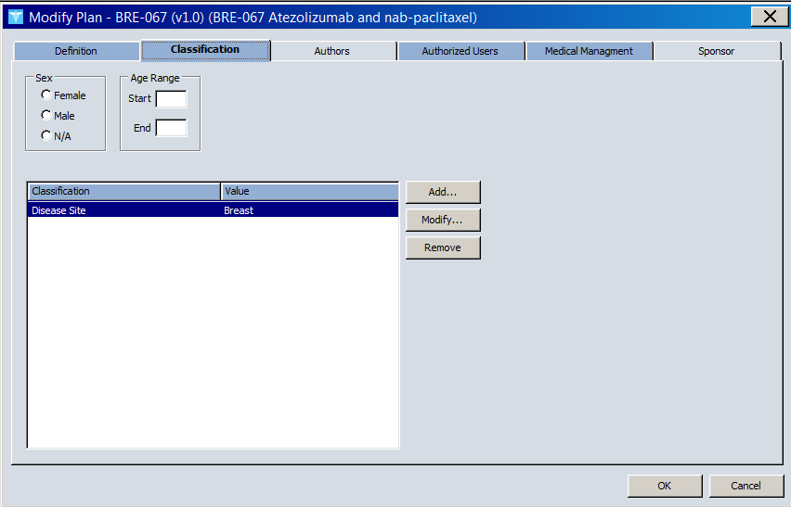  Classification: In the classification box, click on the “Add” button on the right then:  1.2.1  1.2.2  1.2.3  - For SACT regimens – All regimens will need a disease site but not all wil require a cancer category. Refer to KMCCEP006 Regimen classification specification – Disease site and cancer categories document for instructions on which are required for your regimen. Select “Disease Site” from the Classification dropdown box then the relevant cancer disease site(s) from the Value dropdown box. If the regimen is used to treat more than one disease site, this process must be repeated for every disease site. If the disease site has a sub-category, e.g. NSCLC, this also needs to be added by selecting “Cancer Categories” from the Classification dropdown box then selecting the relevant sub-category from the Value dropdown box  - For support regimens - Select “Problems” from the Classification dropdown list then select the relevant symptom from the “Value” dropdown list.  - For Clinical Trial regimens - The disease site should be selected as per the standard builds above. When selecting Cancer Categories for clinical trials, the ‘Clinical Trials –…’ category must be selected for the disease area the clinical trial is studying. e.g. a CT NSCLC lung cancer regimen would have the categories: Disease Site – Lung and Cancer Category – Clinical Trial NSCLC.
 | Authors tab: Leave blank.
 | Authorized Users tab: This will contain the name of the regimen builder. Other authorised users must be added by clicking on the “Add” button on the right. The following users must be added: Caroline Waters, Hayley Paddock, Michelle Archer and Helen Downs, as well as the Varian access user Ks VMS. The validating pharmacists name should NOT appear in this tab at this stage. Contact the system administrator and ask to be removed from the list should your name be present before continuing
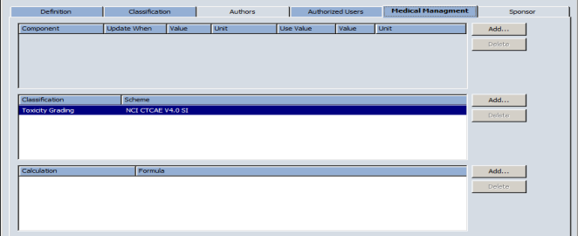
Medical Management tab (SACT regimens only)
1.5.1. | Component: This is usually left blank, unless specific deviations are required from Security set-up, e.g. for clinical trials. This setting may be used to specify different settings, e.g. for GFR. BSA is capped in Security for all regimens at 2m2. It is not possible to set a different BSA cap or to uncap a regimen in this window  1.5.2  1.5.1
1.5.2. | Classification Scheme: This setting cannot be changed after clicking ‘OK’, so ensure that you select the correct one at this stage. For non-trial regimens Add Toxicity Grading scheme of “NCI CTCAE v4.0 SI”.  For clinical trial regimens use the CTCAE version referred to in the protocol. If the protocol CTCAE version is not available on ARIA, the latest version of CTCAE on ARIA must be used.  1.5.3
1.5.3. | Calculation Formula: This box is used to select a specific formula for BSA or GFR calculation for a regimen that will override the standard formulae set up in the Security module. The default formulae set up at Security level are Cockcroft & Gault for GFR calculation and Mosteller for BSA calculation. Other formulas may be required for clinical trial regimens where this has been previously agreed with PI in line with a clinical trial protocol.
 | Medical Management tab (support regimens): Leave blank.
 | Sponsor tab: Leave blank.
BUILDER: SELECT OK TO COMPLETE AND EXIT VALIDATOR: SELECT CANCEL TO LEAVE WINDOW
CLICK ON ‘GO TO’ IN PLAN AGENDA SCREEN
 | VIEW/MODIFY PHASE WINDOW
2.1. | Phase: Automatically numbered as “1”.
2.2. | Phase Name (SACT regimens): Leave as “Phase 1”.
2.3. | Phase Name (support regimens): This is the name the prescriber will see when they select the regimen. Enter the name of the support regimen here. Maximum 20-character limit
2.4. | Purpose: Leave blank.
2.5. | Service Type: Leave blank
2.6. | 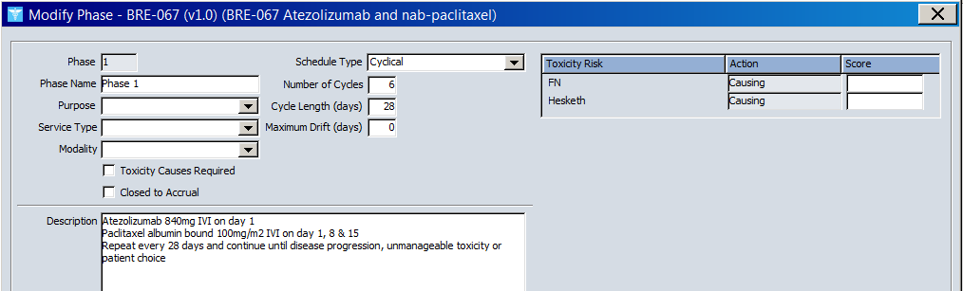  Modality: Select “Radiation” for chemo-radiation regimens. Leave blank for all other regimens.  2.1  2.2 +  2.3  2.4  2.5  2.6  2.7  2.8  2.9  2.10  2.11  2.12  2.13  2.14
2.7. | Toxicity Causes Required: Leave this box unticked.  2.15**
2.8. | Closed to Accrual: Leave this box unticked.
2.9. | Schedule Type: “Cyclical” should be selected for most SACT and support regimens that are repeated at regular intervals for a given number of cycles which can be increased or decreased as necessary. “Linear” applies to treatment courses consisting of a single cycle that will not be repeated or amended. “Linear – Neg. Days” should only be selected for bone marrow transplant regimens or any other regimens that may require treatment on negative day numbers. If “Linear – Neg. Days” is selected, enter the Starting Day for the cycle, e.g. Day -5, instead of the Number of Cycles.
2.10. | Number of Cycles: Enter the number of cycles the regimen should contain as specified on the KMCC SACT protocol. If the number of cycles isn’t fixed, set up according to the list below:  - Regimens for multiple indications with a differing range of cycles depending on indication, should be set up for the lowest number of cycles  - Regimens which continue until disease progression should be set up for 12 months worth of cycles  - Regimens which contain combination treatment cycles followed by single agent cycles until disease progression should be set up with the number of cycles stated on the protocol for the combined treatment, followed by 12 months worth of cycles of the single agent treatment.
2.11. | Cycle Length (days): Specify the cycle length (in days) required for the regimen. ARIA cannot accommodate cycles with differing length in a single regimen so a different regimen will have to be built for each part which is of a different cycle length to the last. e.g. induction cycles of 28 days, consolidation cycles of 21 days and maintenance cycles of 28 days. If the Kent & Medway SACT proforma does not specify the length of a cycle (e.g. some haematology regimens), set cycle length as 28 days. If the protocol states a cycle length of 30 days, the regimen must be built as a cycle length of 28 days so that the cycle start doesn’t fall on a weekend. In such cases, a note should be added to the Admin tab textbox (see 4.2) stating “DISPENSE 30 DAYS SUPPLY”. For clinical trials refer to the clinical trial protocol for cycle length.
2.12. | Maximum Drift (days): Leave as “0” days.
2.13. | Toxicity Risk scores: Leave blank
2.14. | Description box: Leave blank
2.15. | Chemo Order Instructions: Leave blank.
SELECT OK TO SAVE AND CLOSE THE WINDOW
DOUBLE-CLICK ON AGENTS TO OPEN THE AGENTS WINDOW. SELECT ‘NEW’ TO ADD AN AGENT
 | AGENTS
As detailed in the steps below, add NB Monitoring parameters as the first agent then add subsequent drugs as per the order of administration on the reference document, and their agent category, without regard for the day they are due as this will be set later in scheduling. Add all pre-meds first, then all treatment drugs, then all TTO drugs. When adding the agents, bear in mind that the lower the number, the higher the place the drug will appear when prescribed so a drug in position 2 will appear for administration before the drug in position 3 if scheduled on the same day.
3.1. | 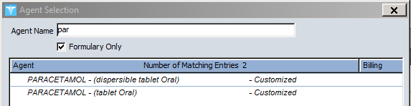  Agent Selection  Leave the “Formulary Only” box ticked and then type in the first 3 letters of the agent name. “NB Monitoring parameters” should be the first agent on all regimens, as this will contain all as the essential prescribing and monitoring guidance. Select required agent from the list then click OK. This will take you to the Add Agent window.  When building a Clinical Trial regimen, the NB monitoring parameters should only specify the location of the local reference protocol for the regimen, it is not necessary to also enter the details into the ARIA agent.  Add subsequent agents ensuring they will appear in the correct order in Manager and include all pre-medications and supportive medicines that are required. If an Internal agent will be scheduled on more than one day in a cycle then this should be added as a single agent entry then scheduled on multiple days. If more than one ‘Internal’ drug is administered more than once in a day then a different drug entry per dose will be required to ensure that the correct administration sequence is given. In addition, if the dose of a drug changes within the regimen, a different agent entry will need to be added for each dose.  When adding agents for clinical trials, all Investigational Medicinal Products (IMP) supplied or reimbursed by the sponsor must include the suffix (Trial). e.g. Lenalidomide (Trial). If the required agent is a novel drug not on the formulary or is on the formulary and does not have the suffix (Trial) then a KMCCEP013 form must be completed and sent to the KMCC e-prescribing team for adding to the system. For all non-IMPs or standard of care stock, the standard agent file should be used. Agents should be added multiple times to a regimen when different strengths/ doses are required; to enable each strength or dose be scheduled at the right times within the regimen.  NB notes: An NB Reminder note should be added for all protocol instructions that are not attached to an agent, see screenshot below as an example of the protocol layout and how it is then built in ARIA. The only NB notes in use are NB Monitoring parameters (see above for guidance on required information) and NB Reminder for all other information e.g. pre-and post treatment line flushes, details of observation period between treatment drugs.  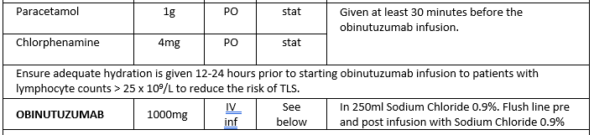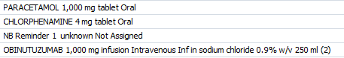
4. | ADD/VIEW / MODIFY AGENT
4.1. | Details Tab
4.1.1. | Agent Name: This will show the agent name as selected on the previous screen.
4.1.2. | Form: The drug form will automatically be selected from the dropdown box, based on your previous selection from the formulary. This field should not be amended.
4.1.3. | 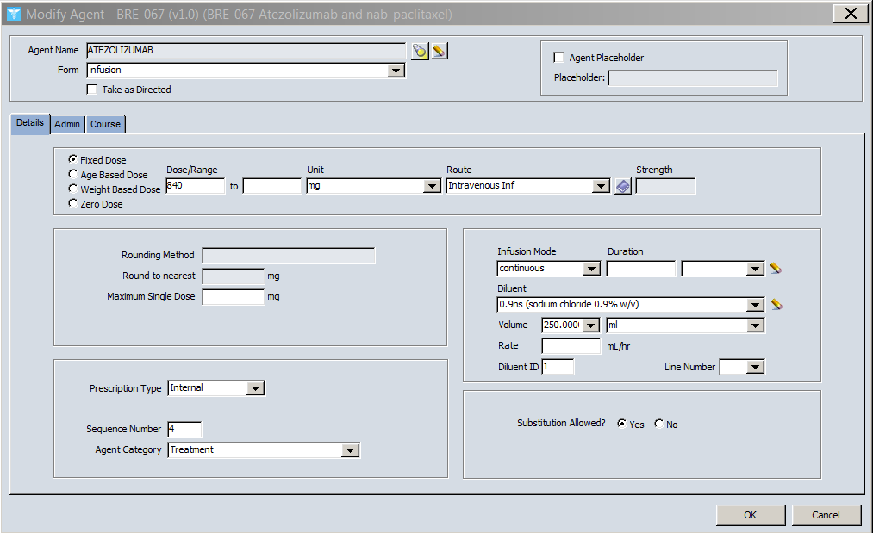  Take as Directed: Whenever possible this box should be left unticked as ticking this box disables the dose/range and unit boxes so doses will not be calculated. Circumstances when the box will have to be ticked include drugs with variable doses, e.g. metoclopramide TDS for 3 days then up to TDS PRN. When the box is ticked, full instructions regarding dose, frequency, duration and administration day would then need to be typed in the Admin tab textbox (see 4.2).  4.1.1  4.1.2  4.1.4  4.1.3  4.1.5  4.1.6  4.1.7  4.1.8  4.1.9  4.1.10  4.1.11  4.1.12  4.1.13  4.1.15  4.1.14
4.1.4. | Agent Placeholder: Leave this box unticked.
4.1.5. | Dose: Always leave the “Fixed Dose” radio button selected then enter the required dose. Filgrastim must be built as a ‘Fixed dose’ of 5mcg/kg. A dose banding table has been applied in Security to band the dose to 300mcg or 480mcg, as appropriate. Carboplatin should be set up with the dose unit selected as “AUC (CrCl)”. Prescribers will manually amend to “AUC (EDTA)” at the prescribing stage if/when an EDTA result is available. Vincristine for adult patients should be set as a flat dose of 2mg for all regimens that currently stipulate a calculated dose of 1.4 or 1.5mg/m2 (the calculated dose must be entered in the admin notes). Vincristine for paediatric patients should be built as per reference protocol. 5-FU pumps should be set up with the total dose to be infused as mg/m2 with the duration entered in the infusion mode duration box below. NB notes should be set up as a ‘Fixed Dose’ of 1, with the Unit dropdown box left blank and the Route dropdown box should be set as “Not Assigned”.
4.1.6. | Dose/Range: Enter the dose in the first Dose/Range box or for a range, enter a value in each box to show dose from and dose to.
4.1.7. | Unit: Enter as per protocol e.g. mg/kg, mg/m2, etc.
4.1.8. | Route: This will auto-populate based on the settings for the chosen drug and MUST NOT be altered.
4.1.9. | Strength dropdown box is usually left blank and cannot be manually entered. The box is only populated if the drug had more than one strength available during agent selection e.g. Co-codamol 8/500 or 30/500
4.1.10. | Rounding: Leave the rounding boxes blank unless the protocol specifies a different rounding or banding schedule should be used, instead of the NHSE ones set up in Security. Dose banding tables should be added to all Cytarabine Injection entries where the standard dose is calculated. Cytarabine infusion entries are already banded at Security level. To add a different banding or rounding schedule, select “Dose Banded” from the Rounding Method dropdown box, then click on the red icon and click on the “Add” button to add each line of the dose banding table as required (see KMCCEP029 Adding dose banding tables to ARIA).
4.1.11. | Maximum Single Dose: A value should be entered here if specified on the protocol and if the agent is not a flat dose. For dose banded drugs, ensure the maximum dose corresponds to a dose band as per the entry in Security. If not, the equivalent dose band should be entered here, with a note added to the admin tab that the protocol maximum dose is NNmg, banded to NNmg on ARIA. Refer to KMCC system admin if unsure. Maximum single doses should not be entered for drugs marked as ‘Take as directed’.
4.1.12. | Prescription Type: Select “Internal” for all preparations that are administered on the ward. Select “Pickup - Internal” for all preparations that are to be supplied to the patient to take home. If Pickup - Internal is selected, leave Record Dose dropdown box as “No Dose Recordings” and leave Refill box unticked. For regimens with ‘Internal’ agents, “NB Monitoring Parameters” must be designated an ‘Internal’ agent. For regimens with only ‘Pickup - Internal’ agents, “NB Monitoring Parameters” must be set up as a ‘Pickup - Internal’ agent.
4.1.13. | Sequence Number: The sequence number will determine the order of administration for all drugs entered for the regimen. Where possible, an agent should only be entered once then scheduled for the appropriate days in Schedule Events window. If you forget to add in a drug during your regimen build, all subsequent sequence numbers must be amended in reverse order before the drug can be added in at the vacant position. If building a clinical trial and adding multiple strengths of the same drug to facilitate titration these should be added consecutively in the relevant sequence in order to ensure they appear on ARIA correctly when scheduled.
4.1.14. | Agent Category (chemo regimens only): Select the correct category for the drug from the dropdown list, e.g. treatment, hydration, etc. When adding an NB note, select “Not Applicable”.
4.1.15. | Substitution Allowed?: Leave the Yes radio button selected.
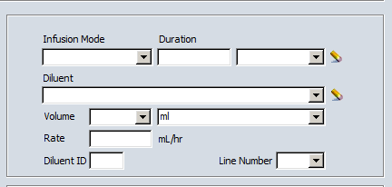
FOR INFUSIONS/INJECTIONS A SET OF BOXES WILL APPEAR, CONTINUE TO POINT 4.1.16 FOR INSTRUCTIONS ON COMPLETION.
FOR ALL OTHER PREPARATIONS, GO TO POINT 4.2.
4.1.16
4.1.17
4.1.18
4.1.19
4.1.20
4.1.16. | Infusion Mode: Selected from the dropdown box: “continuous” should be selected for infusions and “bolus” selected for bolus injections. If the infusion mode is not clearly specified on SACT protocol, use “bolus” for durations of less than 10 minutes and “continuous” for durations of 10 minutes or greater.
4.1.17. | Duration: Enter duration of infusion (where required). The first box is where the numerical field is entered and the second dropdown box is where the units are selected. If the SACT protocol specifies a range for the infusion duration, e.g. bevacizumab, then this field should be left blank and the full infusion details entered in the Admin tab textbox (see 4.2). For 5-FU pumps, enter the infusion mode and duration in hours or days.If you decide to delete the infusion mode or duration after entering, select the ‘eraser’ icon to the right of the dropdown box.
4.1.18. | Diluent and Volume: These should be selected from the dropdown boxes if required. If the SACT protocol specifies a range for the diluent volume, e.g. oxaliplatin, then this field should be left blank and the full infusion details entered in the Admin tab textbox (see 4.2). The Rate field is automatically calculated if both the duration and volume fields have been populated.
4.1.19. | Diluent ID: This box must be completed with a number if a diluent is required. This number should be sequential in terms of the order that the agents are administered in. If two or more agents are to be diluted and administered in the same infusion bag then each agent should be given the same Diluent ID number.
4.1.20. | Line Number: This box should be left blank unless the protocol states a specific line that the drug needs to be administered by if a double or triple lumen line is used and drugs are incompatible.
4.2. | Admin tab: Any additional administration instructions that are included on the protocol but are not specified in the Details tab of the agent entry or in the agent scheduling should be entered here.
4.2.1. | - DO NOT DUPLICATE AGENT OR SCHEDULING INFORMATION HERE except for drugs marked as ‘Take as directed’ where full details of dose, frequency, duration and additional notes should be entered  - For oral SACT drugs with treatment days followed by a rest period within a single cycle, this should be stated in the admin tab as ‘Regimen standard schedule……’  - For ALL vinca alkaloids the following must be stated: “FOR INTRAVENOUS USE ONLY. FATAL IF GIVEN BY ANY OTHER ROUTE.”  - For Pick-Up Internal drugs which start on a day other than day 1, enter the actual start day in the admin instructions.  - Administration times for drugs on an in-patient regimen should be entered here if stated on the protocol, e.g. T=0.  - Do not enter any information in tabular form.  - If a maximum dose has been entered in the agent details, this must also be stated in the admin instructions.  - The protocol standard vincristine dose, e.g. 1.4mg/m2, must be entered in this section in all cases where vincristine has been built as a flat dose of 2mg.  - For drugs with a specified brand e.g. biosimilars, ensure a line is entered for staff to enter the brand supplied  - For Pick-Up Internal drugs which on the protocol state ‘Dispense on cycle 1 then only if required’, this statement must be added to the admin tab  - For clinical trials, specific details as per protocol must be added for each study medication. In addition to this pharmacy details for dispensing should be added here as well if accountability logs or specific vial/kit/pack must be selected. e.g. Pharmacy: Select specific vial numbers and complete accountability log.
4.3. | Course tab: Leave blank.
SELECT OK TO COMPLETE THE AGENT ENTRY THEN REPEAT POINT 4 AS NECESSARY UNTIL ALL REQUIRED AGENTS HAVE BEEN ADDED. ONCE COMPLETED SELECT CLOSE TO RETURN TO THE PLAN AGENDA
4.4. | Reminders (support regimens only): Leave blank
DOUBLE-CLICK ON SCHEDULE EVENTS TO ENTER SCHEDULE EVENTS WINDOW.
 | SCHEDULE EVENTS
 | Schedule Events Window
5.1.1. | 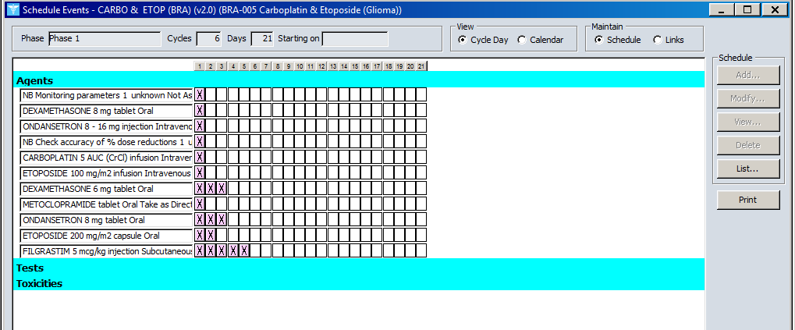  Starting On box: The dropdown box should be left blank at this point. If specific days are selected in the scheduling agents window then the start day will be automatically entered here (see 5.2.3).  5.1.1.  5.1.2.  5.1.3.
5.1.2. | View box: Cycle Day radio button should always be selected.
5.1.3. | Maintain box: Schedule radio button should always be selected.
EACH AGENT NOW NEEDS TO BE SCHEDULED ON THE DAYS IT WILL BE GIVEN. CLICK ON THE RELEVANT TREATMENT DAY BOX ALONGSIDE THE FIRST AGENT AND THEN CLICK THE ADD BUTTON TO OPEN THE ADD EVENT WINDOW.
PICK-UP INTERNAL DRUGS THAT START ON A DAY OTHER THAN DAY 1 MUST BE SCHEDULED ON DAY 1 IRRESPECTIVE OF THE ACTUAL START DAY TO ENABLE THEM TO BE MARKED AS GIVEN TO THE PATIENT. THE ACTUAL START DAY MUST THEN BE STATED IN THE ADMIN TAB. ON CLINICAL TRIAL BUILDS, THE NB MONITORING PARAMETERS ENTRY MUST BE SCHEDULED FOR EACH DAY THE PATIENT WILL ATTEND SITE FOR ADMINISTRATION TO ENSURE TRIAL SPECIFIC CHECKS ARE DONE EACH TIME.
Add Event
5.2.6
5.2.8
5.2.7
5.2.2
5.2.3
5.2.4
5.2.5
5.2.1
5.2.1. | Frequency: Select from drop down list. These boxes are disabled for drugs marked ‘take as directed’.  d  c  b  a  Do not use the frequency “mane”, as it will cause a system error, instead use ‘every am’.  For doses using the frequency of ‘q’ for ‘every’, boxes a and b will also become available to enter a number and a interval type e.g. hours  For Internal drugs given as a single dose per day, including 5FU pumps, select ‘once’
5.2.2 | Duration: Enter numerical duration value in box c and interval type in box d. For all Internal drugs given as a single dose per day, enter 1 in box c and doses in box d. Filgrastim must be scheduled on day 1 for the specified duration - or 5 days, if not specified – irrespective of the actual start day.
5.2.3 | 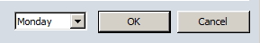  Days of Week: Select appropriate day(s) of the week from the drop-down list (Pick-up Internal drugs only). Once selected, an additional box will appear to select the ‘Starting on’ day. Select Monday in all cases. This will then also appear in the ‘Schedule Events’ window.
5.2.4 | Weekly Frequency: Select from drop-down list if required
5.2.5 | PRN: Tick if drug is PRN, disabled for “Take as directed” drugs
5.2.6 | Quantity: Leave blank
5.2.7 | Volume: Leave blank
5.2.8 | Unit: Leave blank
5.3 | Cyclical tick box:  This box allows you to specify if the drug will be cyclical and given on the selected day on every cycle, or non-cyclical and given on the selected day on specified cycles only. Leave the cyclical box ticked for drugs that will be given on the selected day at every cycle. For Pick-Up Internal drugs that are dispensed on cycle 1 then only if required, schedule these as cyclical to enable them to be dispensed at any cycle, if required. If any part of an agents scheduling will be non-cyclical then all the events for that agent will need to be non-cyclical. For example, if a drug is required on day 1 of all cycles but only on day 8 of cycles 1 & 2, the day 1 scheduling should be made non-cyclical but the drug scheduled on every cycle. If the drug will not be given at every cycle, un-tick the cyclical tick box and specify the cycle number that treatment will be given on using the “Add” button that appears at the bottom.
VALIDATOR: CLICK ON THE “LIST” BUTTON ON THE RIGHT AND CHECK THAT THE EVENT LIST IS DISPLAYING CORRECTLY. THIS LIST WILL SHOW YOU HOW EACH DRUG IS SCHEDULED FOR THIS REGIMEN. SELECTING “CYCLICAL” WILL BRING UP LIST OF ALL AGENTS THAT HAVE BEEN SCHEDULED CYCLICALLY. SELECTING “NON-CYCLICAL” WILL BRING UP LIST OF ALL AGENTS THAT HAVE BEEN SCHEDULED NON-CYCLICALLY. TAKE A SCREENSHOT OF THE LIST(S) AND SEND TO THE KMCC SYSTEM ADMINISTRATOR AND ADMINISTRATOR. THIS LIST WILL THEN BE SENT TO THE VALIDATING NURSE FOR REFERENCE
SELECT OK TO COMPLETE THE SCHEDULING FOR THE AGENT THEN REPEAT POINT 5 UNTIL ALL AGENTS HAVE BEEN SCHEDULED THEN SELECT CLOSE TO RETURN TO THE PLAN AGENDA
 | TESTS: LEAVE BLANK
 | TOXICITIES: LEAVE BLANK
 | TREATMENT MANAGEMENT RULES (SUPPORT REGIMENS ONLY): LEAVE BLANK
SELECT PLAN DETAILS THEN SUMMARY
 | PLAN SUMMARY WINDOW
9.1. | Enter a plan summary to include the following
 | Non-Trials regimen  Regimen name and indication  Treatment intent  Treatment drugs, doses, routes and days  Cycle length and course duration  Details of previous or subsequent regimens if complete treatment not in a single regimen  Signpost to full protocol  Reference(s) document name, version and owner, or website link and date accessed  Change control form number (if applicable) |  |  | Clinical Trial regimens  Trial name with clinical trial suffix-Arm name (if applicable)-regimen name  Trial Protocol version the regimen has been built from  EudraCT number or ISRCTN number for the trial  Protocol long title  Protocol short title  IMP drug names, doses, frequency and routes  Cycle length and duration of treatment for the individual regimen  Intent for use: a summary of the purpose of the regimen e.g. to assess efficacy and safety of arm A vs arm B
10. | PLAN ACCESS WINDOW: SELECT “PLAN DETAILS” THEN “ACCESS” FROM THE MENU AT THE TOP OF THE SCREEN. THIS WINDOW WILL ALLOW YOU TO SPECIFY WHO AND WHERE WILL HAVE ACCESS TO THE REGIMEN THAT YOU HAVE BUILT:
10.1. | Institutions tab: Select either the “TEST LOCATION – OUTPATIENT” location for adult regimens or “TWH Paed – TEST LOCATION” for paediaric regimens.
10.2. | Users tab: Leave all users un-ticked
11. | APPROVE PLAN: SELECT APPROVE FROM THE TOOLBAR THEN THE ANALYSE BUTTON AT THE BOTTOM OF THE SCREEN TO CHECK FOR ANY ERRORS IN THE SET-UP. IF NO PROBLEMS ARE HIGHLIGHTED, CLICK ON THE APPROVE FOR TESTING BUTTON.
BUILDER: LOG IN TO MANAGER AND VISIT THE FOLLOWING WINDOWS TO CHECK THE ACCURACY OF YOUR REGIMEN BUILD. THE FOLLOWING SCREENSHOTS WILL SHOW WHICH PLANNER WINDOW IS USED TO POPULATE WHICH MANAGER WINDOW. ONCE BUILDING IS COMPLETED AND CHECKED, FILL OUT, SIGN AND SUBMIT A BUILDERS CHECKLIST TO THE KMCC ADMINISTRATOR
11.1 |  |  | 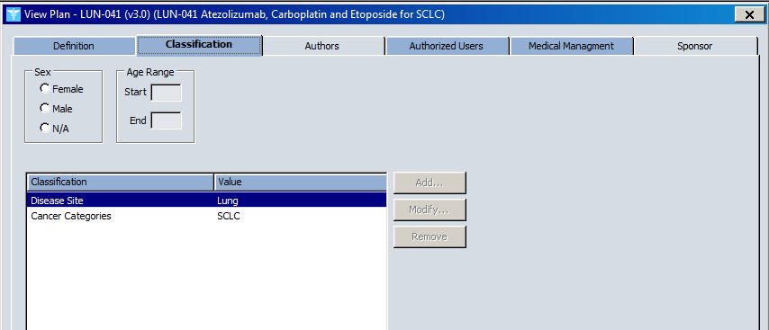  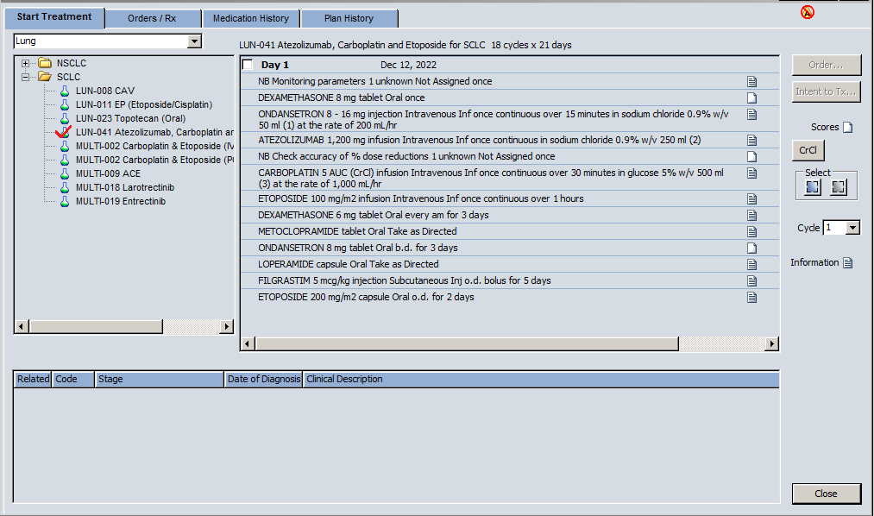  Check the disease site and cancer category (if applicable) are correct  PLANNER  MANAGER  \\\\\\\\\\\
11.2 |  |  | Check the number of cycles and cycle interval are correct  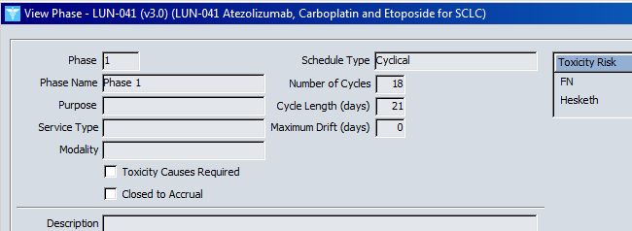  MANAGER  PLANNER
11.3 |  |  | Check the sequence of drugs is correct  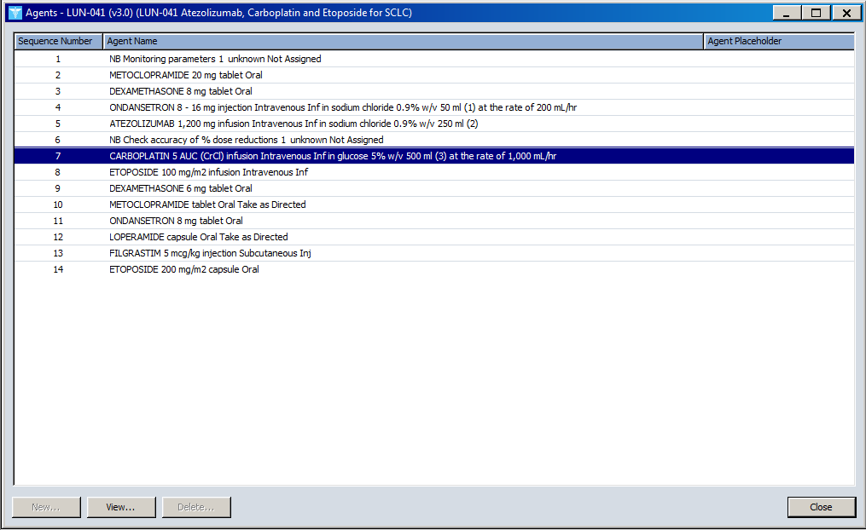+  PLANNER  MANAGER
11.4 |  |  | Check the drug details from the Details tab are correct  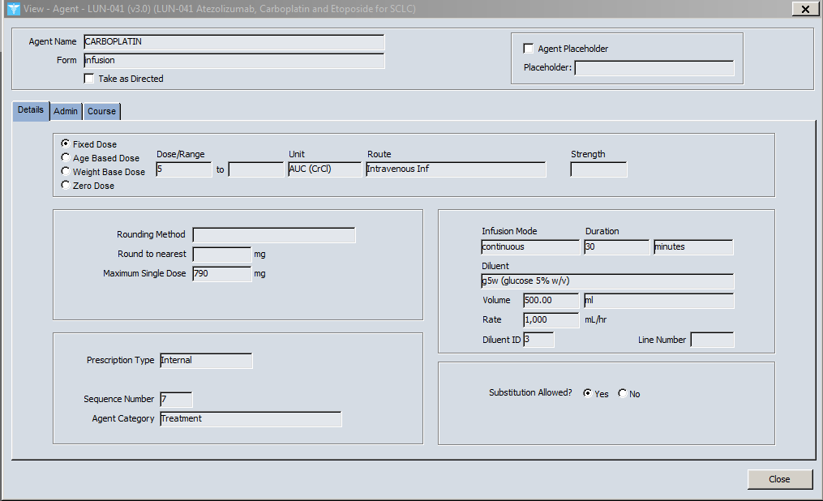  MANAGER  PLANNER  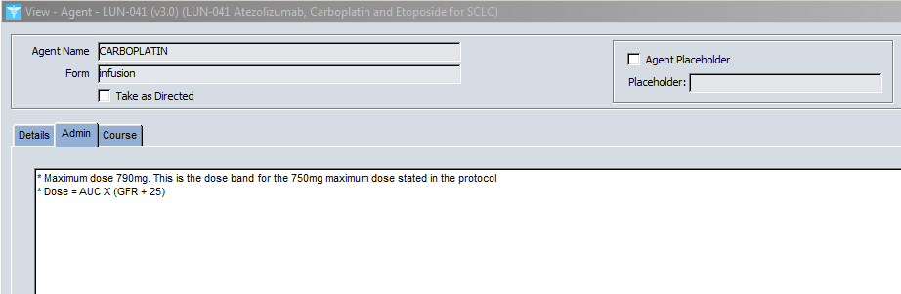  MANAGER  PLANNER
11.5 |  |  | 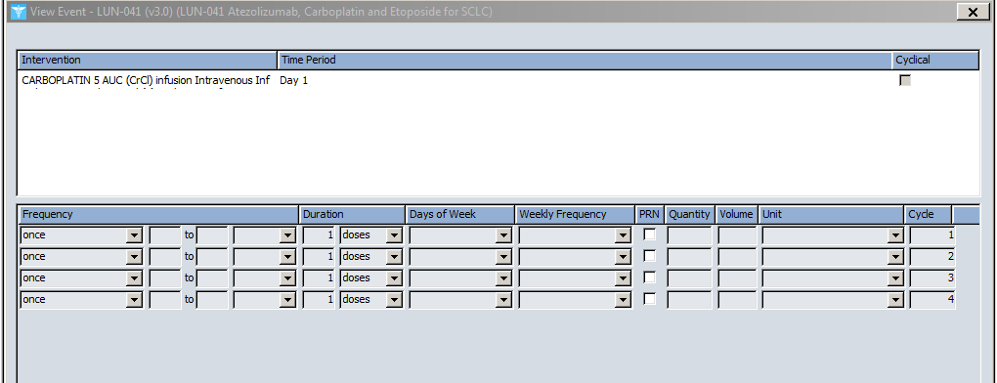  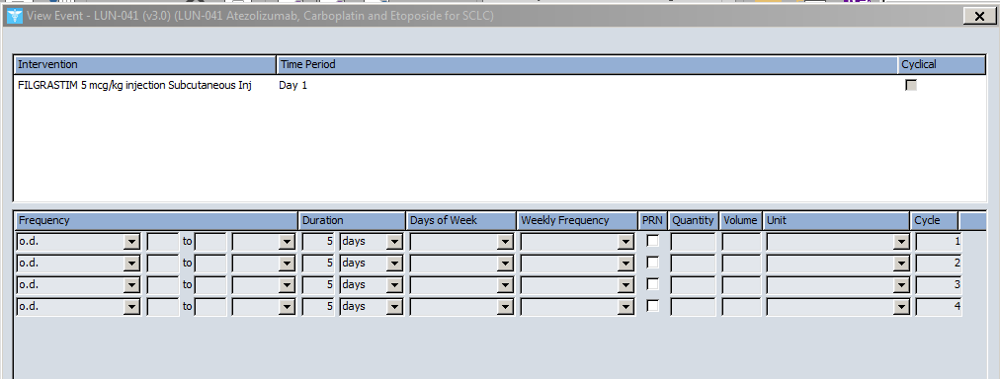  Check the scheduling  PLANNER  PLANNER  MANAGER
11.6 |  |  | Check the Plan Summary  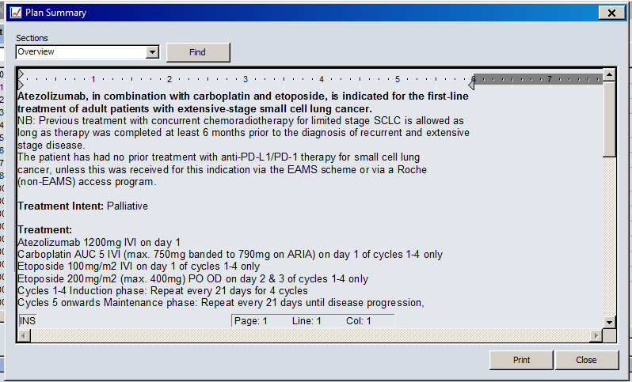  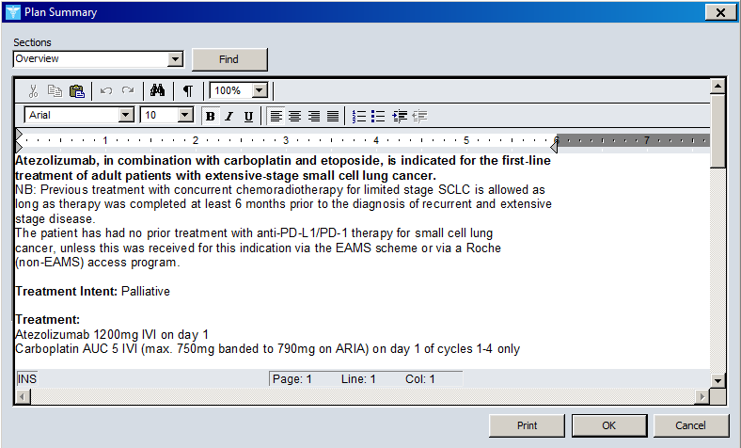  MANAGER  MANAGER  PLANNER
VALIDATING PHARMACIST: INFORM THE KMCC ADMINISTRATOR THAT THE VALIDATION CAN NOW BE SENT TO THE CONSULTANT. IF THE REGIMEN BEING VALIDATED IS A SUPPORT REGIMEN THAT WILL BE USED IN COMBINATION WITH A CHEMO REGIMEN, INFORM THE KMCC ADMINISTRATOR WHO WILL FACILITATE ACCESS
TABLE 2
PHARMACIST VALIDATION
ARIA MANAGER
LOG INTO ARIA MANAGER AT “TEST LOCATION - OUTPATIENT” LOCATION FOR ADULT REGIMENS OR “TWH PAED – TEST LOCATION” FOR PAEDIARIC REGIMENS. CREATE A TEST PATIENT (SEE KMCCEP012 ARIA TEST PATIENT SET UP GUIDE). ENTER VITAL SIGNS FOR THE LARGE PATIENT THEN OPEN THE MEDICATIONS WINDOW
- FOR CHEMOTHERAPY REGIMENS: SELECT THE RELEVANT CANCER DISEASE SITE FOR THE REGIMEN THAT YOU WILL BE TESTING AND HIGHLIGHT THE REGIMEN. CONTINUE TO POINT 12.

- FOR SUPPORT REGIMENS USED IN COMBINATION WITH A CHEMOTHERAPY REGIMEN: SELECT THE SAME CHEMOTHERAPY REGIMEN AS SET UP FOR THE CONSULTANT FROM THE RELEVANT DISEASE SITE FOLDER AND ORDER, THEN FOLLOW POINT c) BELOW. THE FOLLOWING TESTS NEED ONLY BE PERFORMED ON THE SUPPORT REGIMEN DRUGS

- FOR SUPPORT REGIMENS USED AS A STAND-ALONE TREATMENT: GO TO ORDERS/RX TAB THEN SELECT ‘NEW’ BUTTON. FROM THE NEW PRESCRIPTION WINDOW COMPLETE THE “ORDERED BY” FIELD BY SELECTING DR. MD VARIAN THEN SELECT THE FAVORITES BUTTON, SELECT “SUPPORT” THEN CLICK ONCE ON THE REQUIRED PLAN. GO TO POINT 13.
12. |  | CHEMOTHERAPY REGIMENS – START TREATMENT TAB
12.1. |  | 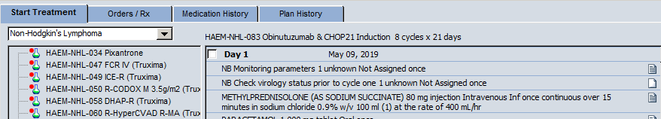  Check that the regimen appears in the correct folder(s) in Manager based on the indication specified in the treatment protocol, e.g. lung NSCLC etc.  For Clinical Trials ensure that the regimen appears in the correct Clinical Trial dropdown for the disease being selected.
12.2. |  | Next to the drop-down menu bar check that the cycle length is correct.
12.3. |  | Check that the standard number of cycles is correct
13. |  | SUPPORT REGIMENS – FAVORITE AGENTS SELECTION
13.1. |  | Check that the support regimen appears in the correct folder
13.2. |  | 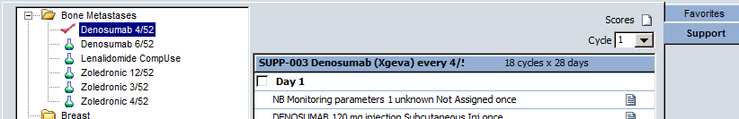  Check that the cycle length is correct
13.3. |  | Check that the standard number of cycles is correct
ORDER YOUR REGIMEN FOR THE TEST PATIENT. IF CYCLE 1 CONTAIN S MULTIPLE TREATMENT DAYS, ALL DAYS SHOULD BE ORDERED
14. |  | DOSE CALCULATION MANAGEMENT WINDOW (If there are no calculated doses (flat dose only) with NO permitted dose reductions, omit test 14)
14.1. |  | For regimens with calculated doses, check that the BSA is capped in the Dose Calculation Management window. This window should automatically open when you first order the regimen. If it does not, then click on the icon in the top right-hand corner
14.2. |  | Uncap the BSA by selecting ‘Use Actual’.
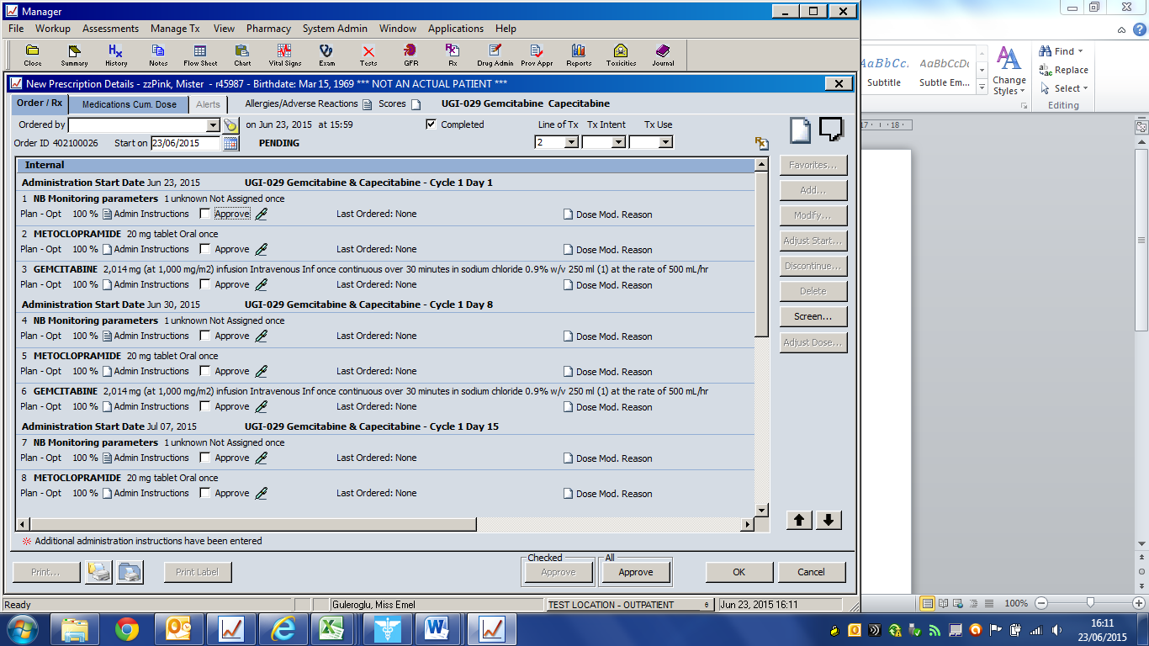
FOR EACH OF THE INDIVIDUAL AGENTS IN THE REGIMEN, CHECK THE FOLLOWING:
(NB: If a support regimen is prescribed in combination with an approved chemotherapy regimen, only the agents in the support regimen should be checked)
15. |  | REVIEW PRESCRIPTION DETAILS WINDOW
15.1. |  | Are all the agents still in the correct administration sequence as shown in Planner? For regimens with more than one scheduled treatment day, all ‘Internal’ agents are listed first, followed by all ‘Pickup - Internal’ agents.
15.2. |  | Are all the agents correct in terms of routes of administration, diluents, infusion volumes and durations?
15.3. |  | 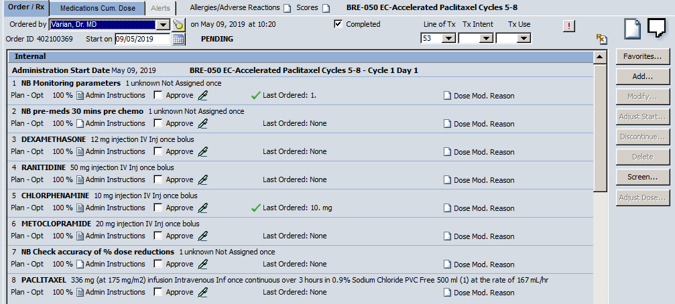  For each agent click on the Administration Instructions box and check that the administration instructions are correct
15.4. |  | Are all the doses that have been calculated by the system based on either BSA/weight/CrCl etc. correct and match what is specified in the regimen and set up in Planner. For Clinical Trials ensure that any regimens built with edited dose calculations are correct and match what is setup in the planner.
15.5. |  | If any of the drugs are dose banded or rounded, check that the dose is as expected”. The dose banding table can be viewed by clicking on the icon.
TAKE A SCREENSHOT OF THE REGIMEN AT 100% dose and actual BSA
CLICK ON THE ICON IN THE TOP RIGHT-HAND CORNER AND SELECT ‘USE CAP’ TO APPLY TO 2M² DOSE CAP
HIGHLIGHT AN AGENT AND CLICK ON THE ‘ADJUST DOSE’ BUTTON AND CHECK THAT THE APPROPRIATE DOSE BANDING OR ROUNDING HAS BEEN APPLIED. If A maximum dose has been specified in the drug entry in Planner, this may override the dose banding. Document any discrepancy on the validation form.
APPROVE THE PRESCRIPTION BY CLICKING ON THE ‘APPROVE ALL’ BUTTON AT THE BOTTOM OF THE SCREEN (THE BLANK DROPDOWN BOXES AT THE TOP OF THE WINDOW NEED TO BE POPULATED FIRST. USE DR MD VARIAN FOR ‘ORDERED BY’). CHECK EACH WINDOW THAT POPS UP DURING THE PRESCRIPTION APPROVAL STAGE.
16. |  | APPROVAL POP-UP WINDOWS (If applicable. Doesn’t appear for all regimens)
16.1. |  | First databank interaction screening window: Check that the Summary tab in the window lists all agents built into the regimen. Any agents excluded from the screening process will have the symbol 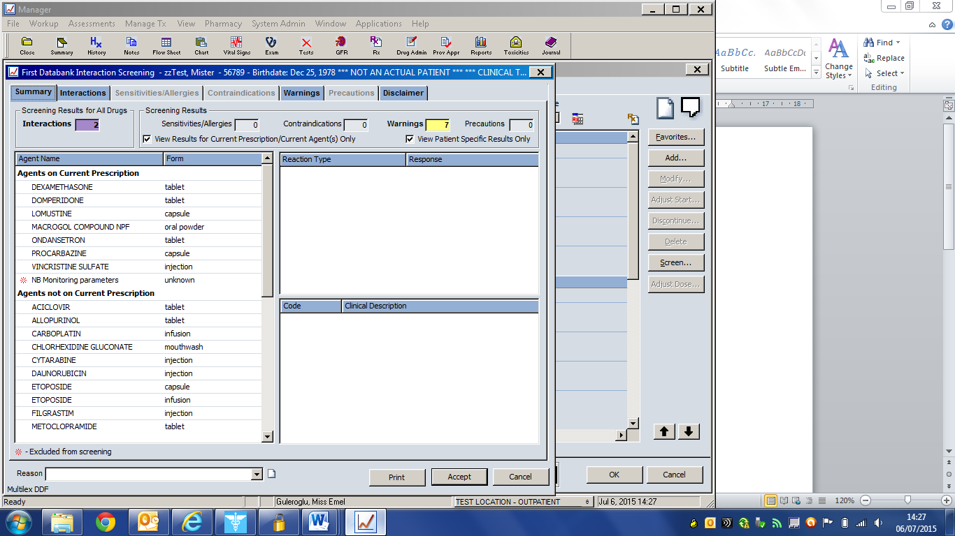 next to their name. This is expected for NB notes, but if any drugs have the symbol next to their name, please document on KMCCEP016 ARIA adult regimen validation and sign-off. Note: It is not necessary to check the clinical accuracy of the screening information. Click on the Accept button once you have checked the Summary tab.
16.2. |  | Prescription Approval/Printing window appears, check that all of the information is correct then click the Approve button.
PHARMACY APPROVE THE ORDER BY CLICKING ON THE ‘APPROVE’ BUTTON ON THE RIGHT, TICKING THE BOX FOR THE APPROPRIATE ORDER, THEN CLICKING APPROVE AGAIN.
CLICK ON THE ‘DISPENSE’ BUTTON ON THE RIGHT HAND SIDE OF THE SCREEN IN THE ORDERS/RX TAB.
17. |  | PRESCRIPTION DISPENSING WINDOW
17.1. |  | Check all the information in the Prescription Dispensing window is correct.
17.2. |  | All agents are listed.
17.3. |  | Are all agents marked correctly as Internal or Pickup - Internal?
17.4. |  | Are all agents to be dispensed in Aseptics correctly marked to indicate this?
CLICK ON THE BLUE 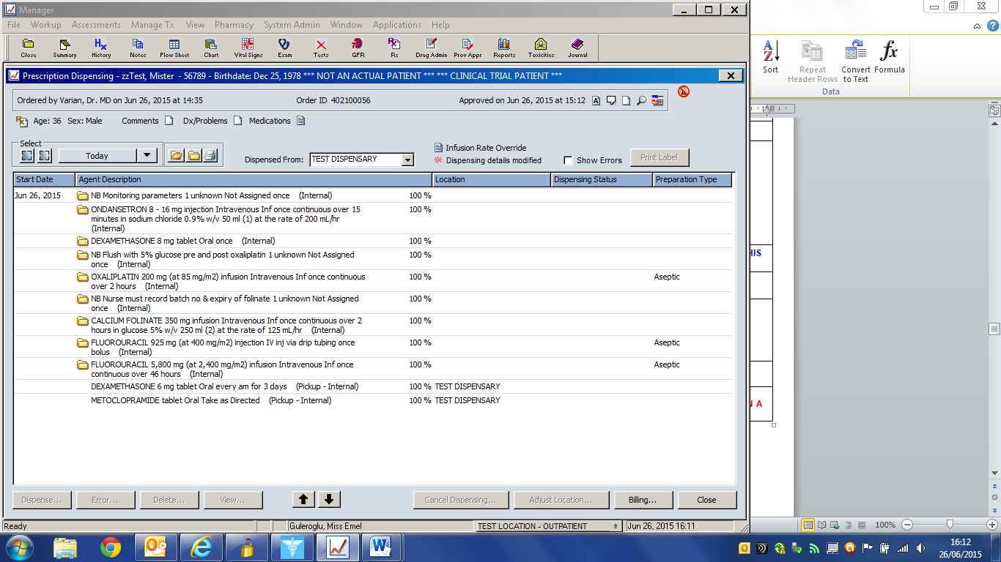 ICON IN THE TOP LEFT-HAND CORNER OF THE DISPENSING WINDOW TO HIGHLIGHT ALL DRUGS, THEN CLICK ON THE ‘DISPENSE’ BUTTON AT THE BOTTOM OF THE WINDOW, AND THEN CLICK ON ‘APPROVE’.
CLOSE THE DISPENSING WINDOWS AND RETURN TO ORDERS/RX. HIGHLIGHT THE APPROPRIATE ORDER THEN SELECT THE PRINTER SYMBOL. TICK TO PRINT INTERNAL, PICK-UP INTERNAL (AS APPROPRIATE) AND PRINT ADMINISTRATION INSTRUCTIONS AND PRINT TO PDF. CHECK THE DOCUMENTS AND SUBMIT WITH OTHER VALIATION PAPERWORK
CLOSE THE DISPENSING WINDOW THEN CLICK ON THE ‘DRUG ADMIN’ BUTTON ON THE TOOLBAR TO ACCESS THE NURSING SCREEN.
IF THE REGIMEN INCLUDES INTERNAL AGENTS THEN CLICK ON THE DAILY ADMINISTRATION TAB AND CONTINUE TO POINT 18
IF THE REGIMEN CONTAINS ONLY PICK-UP INTERNAL AGENTS CLICK ON THE OTHER ADMINISTRATION TAB AND GO TO POINT 19
18. |  | DAILY ADMINISTRATION TAB
18.1. |  | Are all the Internal agents listed in the correct sequence for administration?
18.2. |  | If the regimen includes Internal agents being given on different days in the cycle check that the drug is listed under each appropriate date in the Admin Date box.
19. |  | OTHER ADMINISTRATION TAB
19.1 |  | Are all the Pick-up Internal agents listed? (they will be in alphabetical order per treatment day)
IF THE REGIMEN CONSISTS OF CYCLES SET UP DIFFERENTLY (E.G. FEC-T), EACH DIFFERENT CYCLE MUST BE TESTED BY REPEATING SECTIONS 14 ONWARDS
COMPLETE KMCCEP016 ARIA adult and paediatric regimen validation and sign-off AND RETURN TO SYSTEM ADMINISTRATOR

Regimen name | Click or tap here to enter text. | Regimen version |  | Regimen Date | Enter Date
Test Patient name | Click or tap here to enter text. | Cycles to be ordered | Click or tap here to enter text.
References used | Click or tap here to enter text.

LOG IN TO ARIA MANAGER AT EITHER THE “TEST LOCATION – OUTPATIENT” LOCATION FOR ADULT REGIMENS OR “TWH PAED – TEST LOCATION” FOR PAEDIATRIC REGIMENS AND OPEN THE RECORD OF THE TEST PATIENT STATED ABOVE THEN GO TO THE “RX” ICON
An agent list and event list will be sent along with the validation paperwork. The list of agents will show how many drugs are in the regimen and the event list will show how often they are scheduled. All drugs must be fully checked on the first occasion that they appear following the steps below. On subsequent occurences, only their scheduling and position in the prescription being correct as per the reference protocol needs to be checked as all other information will remain the same regardless of when it is scheduled. For example, if there is a single gemcitabine drug entry and gemcitabine is scheduled on days 1, 8, 15 & 22 of the cycle, the drug details and admin instructions need to be checked on day 1, then only the scheduling and drug position needs to be checked on day 8, 15 & 22

CHECKLIST 1
ACTION |  |  |  |  |  | or
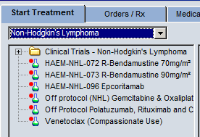
Select the tumour site folder then the regimen to be tested by clicking on it once. The required regimen will have a red dot next to it to indicate that it is in testing
A. | Does the regimen appear in the correct folder(s)?
B. | Next to the drop down menu bar check that the cycle length is correct?
C. | Is the standard number of cycles correct?
D. | Do all treatment days appear and are the appropriate drugs listed for each day?
E. | Click on the Information text box on the right-hand side to open up the Plan Summary window. Check that all of the information is correct and matches the treatment protocol. This should include: Regimen name and indication, treatment drugs, doses, routes and days, treatment intent, cycle length and course duration, references (including change control), signpost to full protocol
ORDER THE REGIMEN FOR THE TEST PATIENT, THEN CHECK THE FOLLOWING
F. | For each drug, are the following details correct, where applicable? Form, Administration route, Frequency, Diluent type and volume, Infusion duration
G. | Are all doses, flat and calculated, correct according to the protocol?
H. | If there are any drug-specific administration instructions, check that they are correct by clicking on the Admin instructions
COMPLETE THE ‘ORDERED BY’, ‘START ON’ (ENTER TODAY’S DATE), ‘LINE OF TX’, ‘TX INTENT’ AND ‘TX USE’ FIELDS, THEN CLICK ‘APPROVE ALL’ BUTTON TO APPROVE THE TREATMENT CYCLE.
I. | In the ‘Treatment’ tab, does the approved cycle appear as ordered
J. | If the cycle consists of multiple treatment days are these scheduled at the correct intervals?
IF THE REGIMEN CONSISTS OF CYCLES SET UP DIFFERENTLY EACH DIFFERENT CYCLE MUST BE TESTED BY ORDERING EACH CYCLE AND REPEATING SECTIONS F-J FOR ALL CYCLES SPECIFIED ABOVE
ERRORS/COMMENTS |  |  | Click or tap here to enter text.
I confirm that the regimen has passed all required tests
Validation Completed by |  | Click or tap here to enter text. |  | Signed | Click or tap here to enter text.
Designation |  | Click or tap here to enter text. |  | Date

Regimen name | Click or tap here to enter text. | Regimen version |  | Regimen Date | Enter Date
Test Patient name | Click or tap here to enter text. | Cycles to be ordered | Click or tap here to enter text.
References used | Click or tap here to enter text.

LOG IN TO ARIA MANAGER AT EITHER THE “TEST LOCATION – OUTPATIENT” LOCATION FOR ADULT REGIMENS OR “TWH PAED – TEST LOCATION” FOR PAEDIATRIC REGIMENS AND OPEN THE RECORD OF THE TEST PATIENT STATED ABOVE THEN GO TO THE “RX” ICON
FOR SUPPORT REGIMENS THAT WILL BE PRESCRIBED WITH A REGIMEN, SELECT THE ORDERS/RX TAB, HIGHLIGHT THE PENDING ORDER AND SELECT MODIFY
FOR SUPPORT REGIMENS THAT WILL BE PRESCRIBED ALONE SELECT THE ORDERS/RX TAB THEN ‘NEW’ BUTTON
FROM THE NEW PRESCRIPTION WINDOW COMPLETE THE “ORDERED BY” FIELD BY SELECTING DR. MD VARIAN
An agent list and event list will be sent along with the validation paperwork. The list of agents will show how many drugs are in the regimen and the event list will show how often they are scheduled. All drugs must be fully checked on the first occasion that they appear following the steps below. On subsequent occurences, only their scheduling and position in the prescription being correct as per the reference protocol needs to be checked as all other information will remain the same regardless of when it is scheduled. For example, if there is a single gemcitabine drug entry and gemcitabine is scheduled on days 1, 8, 15 & 22 of the cycle, the drug details and admin instructions need to be checked on day 1, then only the scheduling and drug position needs to be checked on day 8, 15 & 22

CHECKLIST 2
ACTION |  |  |  |  |  | or
SELECT THE FAVORITES BUTTON, SELECT “SUPPORT” THEN CLICK ONCE ON THE REQUIRED PLAN
A. | Does the regimen appear in the correct folder(s)?
B. | Next to the drop down menu bar check that the cycle length is correct?
C. | Is the standard number of cycles correct?
ORDER THE REGIMEN FOR THE TEST PATIENT, THEN CHECK THE FOLLOWING
D. | For each drug, are the following details correct, where applicable? Form, Administration route, Frequency, Diluent type and volume, Infusion duration
E. | Are all doses, flat and calculated, correct according to the protocol?
F. | If there are any drug-specific administration instructions, check that they are correct by clicking on the Admin instructions
COMPLETE THE ‘ORDERED BY’, ‘START ON’ (ENTER TODAY’S DATE), ‘LINE OF TX’, ‘TX INTENT’ AND ‘TX USE’ FIELDS, THEN CLICK ‘APPROVE ALL’ BUTTON TO APPROVE THE TREATMENT CYCLE.
G. | In the ‘Treatment’ tab, does the approved cycle appear as ordered
H. | If the cycle consists of multiple treatment days are these scheduled at the correct intervals?
I. | Click on the green pen on the left of the screen next to the support regimen name and select ‘Show Summary’. Check that all of the information is correct and matches the treatment protocol. This should include: Regimen name and indication, Treatment drugs, doses, routes and days,Treatment intent, Cycle length and course duration, References (including change control), Signpost to full protocol
IF THE REGIMEN CONSISTS OF CYCLES SET UP DIFFERENTLY EACH DIFFERENT CYCLE MUST BE TESTED BY ORDERING EACH CYCLE AND REPEATING SECTIONS F-J FOR ALL CYCLES SPECIFIED ABOVE
ERRORS/COMMENTS |  |  | Click or tap here to enter text.
I confirm that the regimen has passed all required tests
Validation Completed by |  | Click or tap here to enter text. |  | Signed | Click or tap here to enter text.
Designation |  | Click or tap here to enter text. |  | Date

Regimen name | Click or tap here to enter text. | Regimen version |  | Regimen Date | Enter Date
Test Patient name | Click or tap here to enter text. | Cycles to be checked |  | Cycles to be administered
References used | Click or tap here to enter text.

LOG IN TO ARIA MANAGER AT EITHER THE “TEST LOCATION – OUTPATIENT” LOCATION FOR ADULT REGIMENS OR “TWH PAED – TEST LOCATION” FOR PAEDIATRIC REGIMENS AND OPEN THE RECORD OF THE TESTPATIENT STATED ABOVE THEN GO TO THE “RX” ICON
NOTE: IF YOU ARE VALIDATING A SUPPORT REGIMEN THAT HAS BEEN ORDERED WITH A CHEMOTHERAPY REGIMEN, THE VALIDATION CHECKS ONLY NEED TO BE COMPLETED ON THE SUPPORT REGIMEN AGENTS
An agent list and event list will be sent along with the validation paperwork. The list of agents will show how many drugs are in the regimen and the event list will show how often they are scheduled. All drugs must be fully checked on the first occasion that they appear following the steps below. On subsequent occurences, only their scheduling and position in the prescription being correct as per the reference protocol needs to be checked as all other information will remain the same regardless of when it is scheduled. For example, if there is a single gemcitabine drug entry and gemcitabine is scheduled on days 1, 8, 15 & 22 of the cycle, the drug details and admin instructions need to be checked on day 1, then only the scheduling and drug position needs to be checked on day 8, 15 & 22

CHECKLIST 3
ACTION |  |  |  |  |  | , or N/A
OPEN THE DRUG ADMINISTRATION WINDOW AND COMPLETE THE FOLLOWING CHECKS AS APPROPRIATE
FOR CYCLES TO BE ADMINISTERED: COMPLETE STEPS A-G
FOR CYCLES TO BE TESTED: COMPLETE STEPS A-F
DAILY ADMININSTRATION TAB
A. | Are all the drugs listed in the correct sequence for administration?
B. | For each drug, are the following details correct, where applicable? Form, Administration route, Frequency, Diluent type and volume, Infusion duration
C. | If there are any drug-specific administration instructions, check that they are correct by clicking on the Admin instructions
OTHER ADMINISTRATION TAB
D. | Are all the Pick-up Internal (TTO) drugs listed here? (drugs will appear in alphabetical order)
E. | Check that all drugs have the correct dose, form, route of administration, frequency, infusion rate, diluent information, and administration instructions (where applicable). If there is a stated maximum dose for a drug on the protocol, ensure this is also stated in the admin instructions
F. | If the regimen includes some Pickup - Internal agents being given on different days, e.g. Vinorelbine oral given on Day 1 and Day 8, check that all days of treatment are listed and that the information is correct, and the drug is being administered on the correct day(s).
IN THE “DAILY ADMINISTRATION” AND “OTHER ADMINISTRATION” WINDOWS RECORD EACH AGENT FOR THE CYCLE STATED ABOVE AS ADMINISTERED BY SELECTING EACH AGENT, CLICKING ON THE “RECORD” BUTTON, ENTERING AN ADMINISTRATION TIME AND CLICKING ON THE “APPROVE” BUTTON.
MEDICATION HX TAB
G. | Are all of the administered drugs listed in the appropriate sections, i.e. all anti-cancer drugs listed under ‘Active Chemotherapy Agents’ and all other supportive drugs and warning notes listed under ‘Active Non-Chemotherapy Agents’? NB: For support regimens, all agents become ‘Inactive Agents’ immediately after administration
ERRORS/COMMENTS |  |  | Click or tap here to enter text.
FOR NEW REGIMENS, COMPLETE AND SUBMIT A KOMS NEW EVENT REQUEST FORM
I confirm that the regimen has passed all required tests
Validation Completed by |  | Click or tap here to enter text. |  | Signed | Click or tap here to enter text.
Designation |  | Click or tap here to enter text. |  | Date

